機械所設計組 R12522615 王邑安 HW_ID:2

**Introduction to statistical control and optimization**

Homework 4



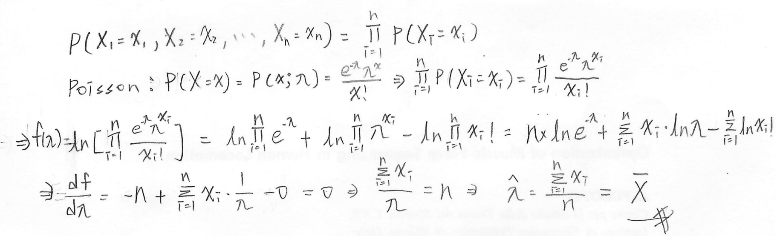



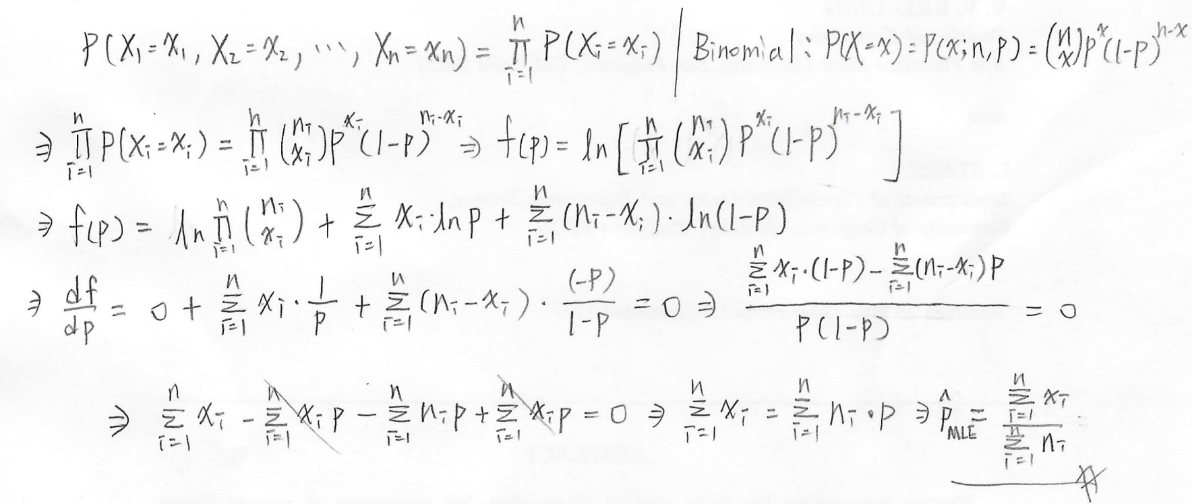



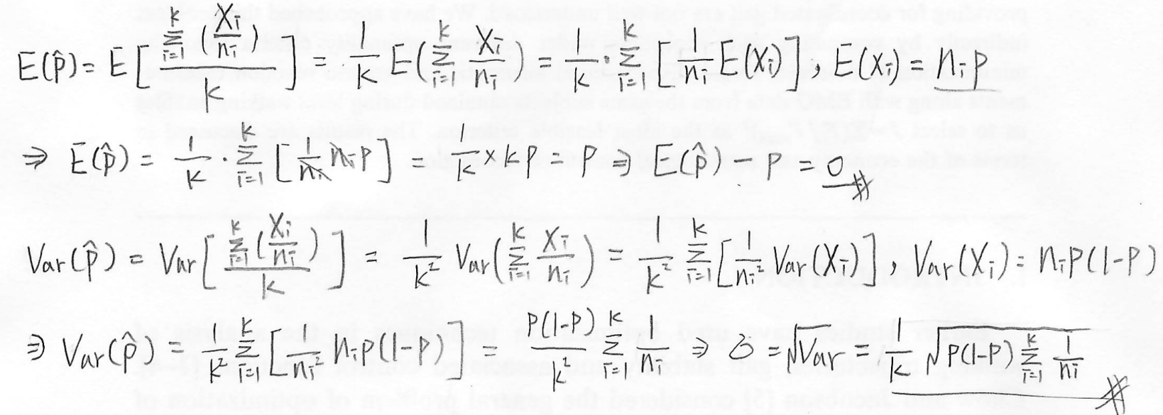

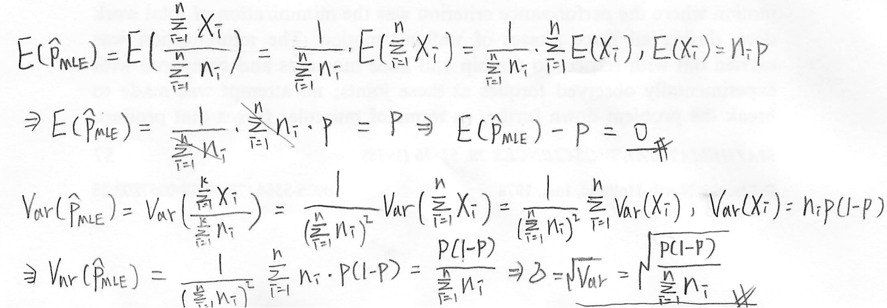



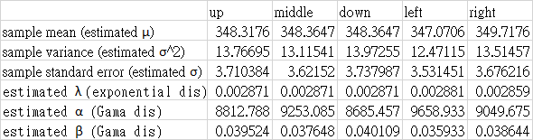



$$Exponential distribution: E(X)=\frac{1}{λ} , Var(X)=\frac{1}{λ^{2}} →\hat{λ}=\frac{1}{\overline{X}}$$

$$f\left(x;λ\right)=λe^{-λx}→F\left(x\right)=\int_{0}^{∞}{λe^{-λx}dx=1-e^{-λx}}, x≥0$$

$$1-p=e^\{-λx\}→ln(1-p)=-λx →F^\{-1\}(p)=\frac{ln(1-p)}{-λ}$$

$$Gamadistribution:E\left(X\right)=αβ,Var\left(X\right)=αβ^{2}→\hat{α}=\frac{{\overline{X}}^{2}}{s^{2}} , \hat{β}=\frac{s^{2}}{\overline{X}}$$

Both the (Q-Q) plots of the thickness, whether dependent on Normal distribution or Gamma distribution, exhibit a strong tendency to align with the 45-degree line. I believe both models effectively capture the random nature of thickness at different positions.







$$Geometric distribution:E\left(X\right)=\frac{1}{p},Var\left(X\right)=\frac{1-p}{p^{2}} → \hat{p}=\frac{1}{\overline{X}}$$

$$Negative Binomial distribution:E\left(X\right)=\frac{r\left(1-p\right)}{p},Var\left(X\right)=\frac{r\left(1-p\right)}{p^{2}}→\hat{p}=\frac{\overline{X}}{s^{2}},\hat{r}=\frac{\overline{X∙}p}{\left(1-p\right)}$$

$$Poisson distribution:E\left(X\right)=λ,Var\left(X\right)=λ→\hat{λ}=\overline{X}$$

Overall, the P-P plot of the Negative Binomial distribution model closely aligns with the 45-degree line. Therefore, I believe that the Negative Binomial distribution is the most appropriate model to describe the accident deaths in these five regions.











In the t-distribution of the left side in the central zone, the upper bound of the 90% confidence interval remains below the target (350). I suspect that the thickness mean is indeed deviating from the target.

The 90% confidence intervals of the left side and right side do not overlap with each other. I am confident in asserting that the means of the two thicknesses are different.